WEEK-1: HTML Frames: Frame Structure: Design a webpage for the online book store using HTML frames. Include a navigation frame, a content frame for displaying book details, and a footer frame for additional information.
Code:
WEEK1.html:
<!DOCTYPE html>
<html>
<head>
<title>Online Book Store</title>
</head>
<frameset rows="20%,70%,10%" border="2">
<iframe src=""></iframe>
<frame src="navigation.html" name="navFrame">
<frame src="content.html" name="contentFrame">
<frame src="footer.html" name="footerFrame">
</frameset>
</html>
Navigation.html:
<!DOCTYPE html>
<html>
<head>
<title>Navigation</title>
</head>
<body bgcolor="BBBBBB">
<h3>Book Categories</h3>
<h1>Hello World Welcome to VNRVJIET</h1>
<ul>
<li><a href="https://www.microsoft.com" target="contentFrame">Computer Science</a></li>
<li><a href="https://www.ieee.org target="contentFrame">Electronics</a></li>
<li><a href="content.html" target="contentFrame">Mechanical</a></li>
<li><a href="content.html" target="contentFrame">Civil</a></li>
</ul>
</body>
</html>

Footer.html:
<!DOCTYPE html>
<head>
<title>Footer</title>
</head>
<body bgcolor="90EE90" align="center">
<p>2025 Online Book Store | Contact: Support@bookstore.com</p>
</body>
</html>

Content.html:
<!DOCTYPE html>
<html lang="en">
<head>
<meta charset="UTF-8">
<title>Book Store</title>
<link rel="stylesheet" href="content.css">
</head>
<body>

<section class="categories">
<h2>Book Categories</h2>
<ul>
<li>Fiction</li>
<li>Non-Fiction</li>
<li>Science</li>
<li>Technology</li>
<li>Children</li>
</ul>
</section>

<section class="books">
<h2>Available Books</h2>
<table>
<tr>
<th>Book Name</th>
<th>Author</th>
<th>Price</th>
<th>Buy</th>
</tr>
<tr>
<td>The Alchemist</td>
<td>Paulo Coelho</td>
<td>$12</td>
<td><button>Buy</button></td>
</tr>
<tr>
<td>Atomic Habits</td>
<td>James Clear</td>
<td>$15</td>
<td><button>Buy</button></td>
</tr>
<tr>
<td>Clean Code</td>
<td>Robert C. Martin</td>
<td>$20</td>
<td><button>Buy</button></td>
</tr>
</table>
</section>

<section class="order">
<h2>Order a Book</h2>
<form>
<label>Full Name</label>
<input type="text" required>

<label>Email</label>
<input type="email" required>

<label>Select Book</label>
<select>
<option>The Alchemist</option>
<option>Atomic Habits</option>
<option>Clean Code</option>
</select>

<label>Quantity</label>
<input type="number" min="1" value="1">

<button type="submit">Place Order</button>
</form>
</section>

</body>
</html>

WEBPAGE:
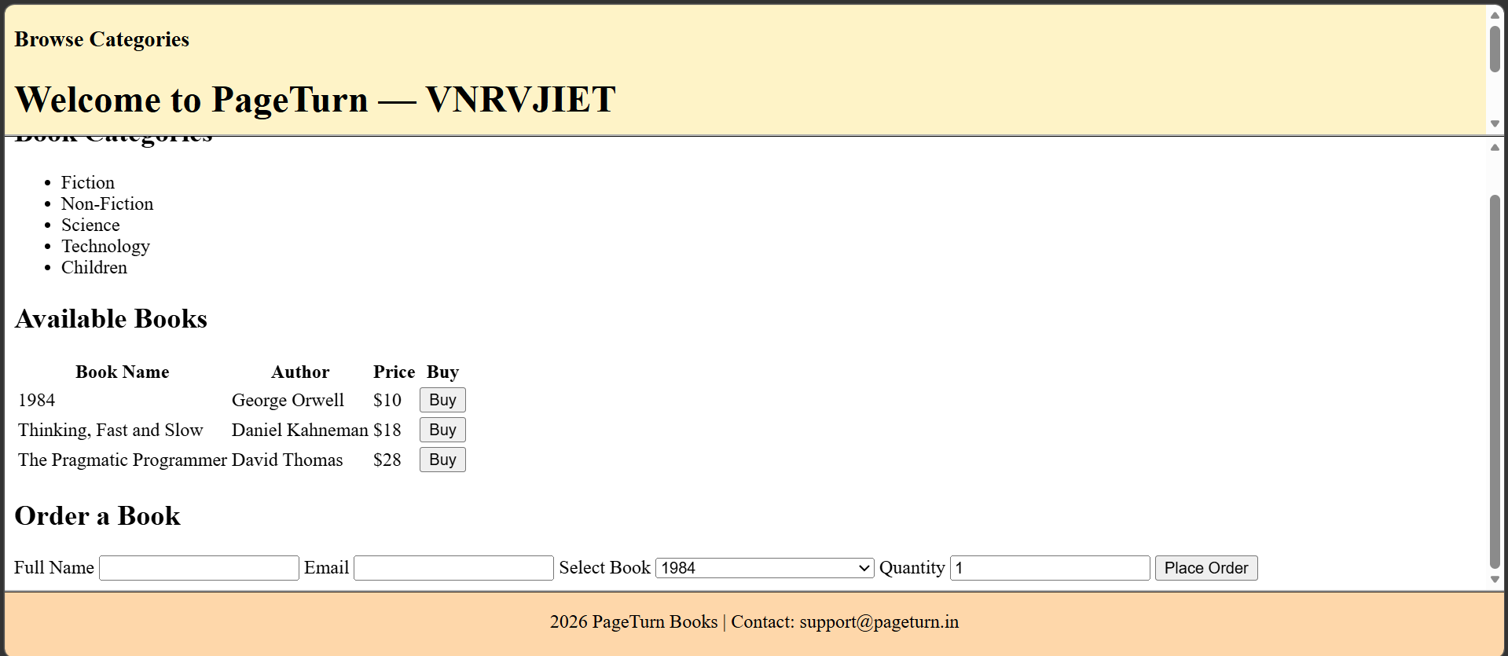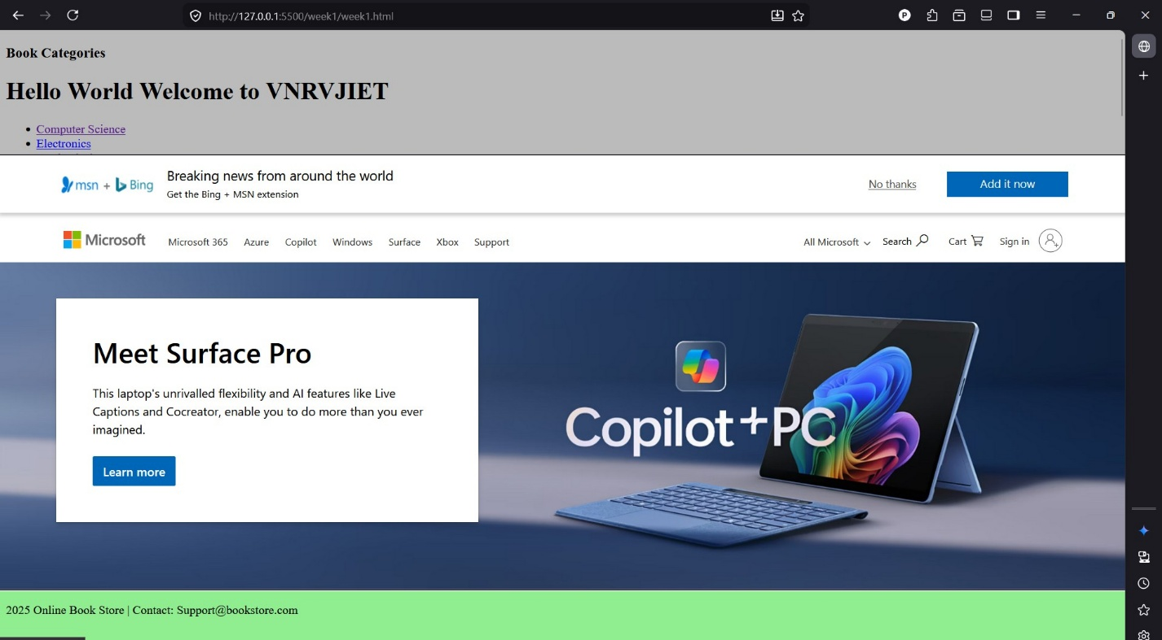

WEEK-2: CSS Styling: Apply CSS styling to enhance the visual appeal of the frames and content. Use appropriate styles for fonts, colors, and layout.
Week2.html:
<!DOCTYPE html>
<html>
<head>
<title>Online Book Store</title>
</head>
<frameset rows="20%,70%,10%" border="2">
<iframe src=""></iframe>
<frame src="navigation.html" name="navFrame">
<frame src="content.html" name="contentFrame">
<frame src="footer.html" name="footerFrame">
</frameset>
</html>
Navigation.html:
<!DOCTYPE html>
<html>
<head>
<title>Navigation</title>
</head>
<body bgcolor="BBBBBB">
<h3>Book Categories</h3>
<h1>Hello World Welcome to VNRVJIET</h1>
<ul>
<li><a href="https://www.google.com" target="contentFrame">Computer Science</a></li>
<li><a href="content.html" target="contentFrame">Electronics</a></li>
<li><a href="content.html" target="contentFrame">Mechanical</a></li>
<li><a href="content.html" target="contentFrame">Civil</a></li>
</ul>
</body>
</html>

Navigation.css:
body {
font-family: Arial, sans-serif;
background-color: #eeeeee;
padding: 10px;
}

h3 {
color: #2c3e50;
}

ul {
padding-left: 15px;
}

li {
margin: 6px 0;
}

a {
text-decoration: none;
color: #2980b9;
}

a:hover {
text-decoration: underline;
}
Footer.html:
<!DOCTYPE html>
<head>
<title>Footer</title>
</head>
<body bgcolor="90EE90" align="center">
<p>2025 Online Book Store | Contact: Support@bookstore.com</p>
</body>
</html>
Footer.css:
body {
font-family: Arial, sans-serif;
background-color: #90EE90;
margin: 0;
text-align: center;
}

p {
font-size: 14px;
padding-top: 10px;
}
Content.html:
<!DOCTYPE html>
<html lang="en">
<head>
<meta charset="UTF-8">
<title>Book Store</title>
<link rel="stylesheet" href="content.css">
</head>
<body>

<!-- Categories List -->
<section class="categories">
<h2>Book Categories</h2>
<ul>
<li>Fiction</li>
<li>Non-Fiction</li>
<li>Science</li>
<li>Technology</li>
<li>Children</li>
</ul>
</section>

<!-- Books Table -->
<section class="books">
<h2>Available Books</h2>
<table>
<tr>
<th>Book Name</th>
<th>Author</th>
<th>Price</th>
<th>Buy</th>
</tr>
<tr>
<td>The Alchemist</td>
<td>Paulo Coelho</td>
<td>$12</td>
<td><button>Buy</button></td>
</tr>
<tr>
<td>Atomic Habits</td>
<td>James Clear</td>
<td>$15</td>
<td><button>Buy</button></td>
</tr>
<tr>
<td>Clean Code</td>
<td>Robert C. Martin</td>
<td>$20</td>
<td><button>Buy</button></td>
</tr>
</table>
</section>

<!-- Order Form -->
<section class="order">
<h2>Order a Book</h2>
<form>
<label>Full Name</label>
<input type="text" required>

<label>Email</label>
<input type="email" required>

<label>Select Book</label>
<select>
<option>The Alchemist</option>
<option>Atomic Habits</option>
<option>Clean Code</option>
</select>

<label>Quantity</label>
<input type="number" min="1" value="1">

<button type="submit">Place Order</button>
</form>
</section>

</body>
</html>
Content.css:
/* General page styling */
body {
font-family: Arial, sans-serif;
background-color: #f5f7fa;
margin: 0;
padding: 15px;
color: #333;
}

/* Section styling */
section {
background: #ffffff;
padding: 15px;
margin-bottom: 20px;
border-radius: 6px;
box-shadow: 0 2px 6px rgba(0,0,0,0.1);
}

/* Headings */
h2 {
color: #2c3e50;
margin-bottom: 10px;
border-bottom: 2px solid #3498db;
padding-bottom: 5px;
}

/* Categories list */
.categories ul {
list-style-type: square;
padding-left: 20px;
}

.categories li {
margin: 5px 0;
}
/* Table styling */
table {
width: 100%;
border-collapse: collapse;
}

th {
background-color: #3498db;
color: white;
padding: 8px;
}

td {
padding: 8px;
border-bottom: 1px solid #ddd;
}

/* Buttons */
button {
background-color: #2ecc71;
color: white;
border: none;
padding: 6px 12px;
border-radius: 4px;
cursor: pointer;
}

button:hover {
background-color: #27ae60;
}

/* Form styling */
form {
display: grid;
row-gap: 8px;
}

input, select {
padding: 6px;
border: 1px solid #ccc;
border-radius: 4px;
}
WEBPAGE:
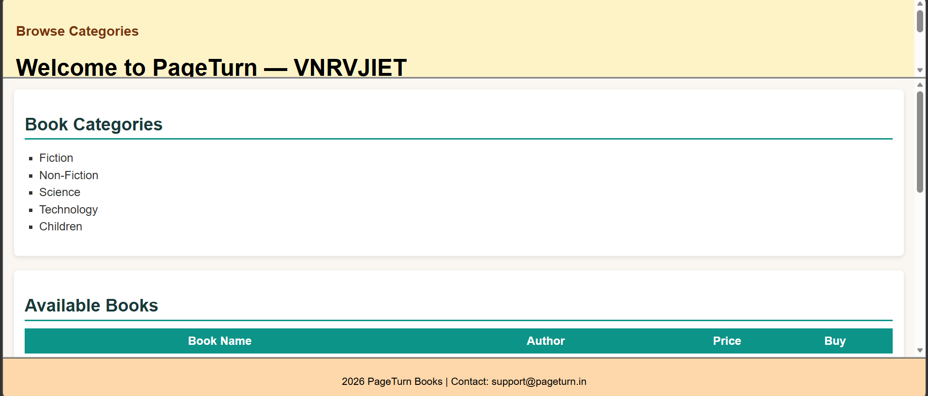
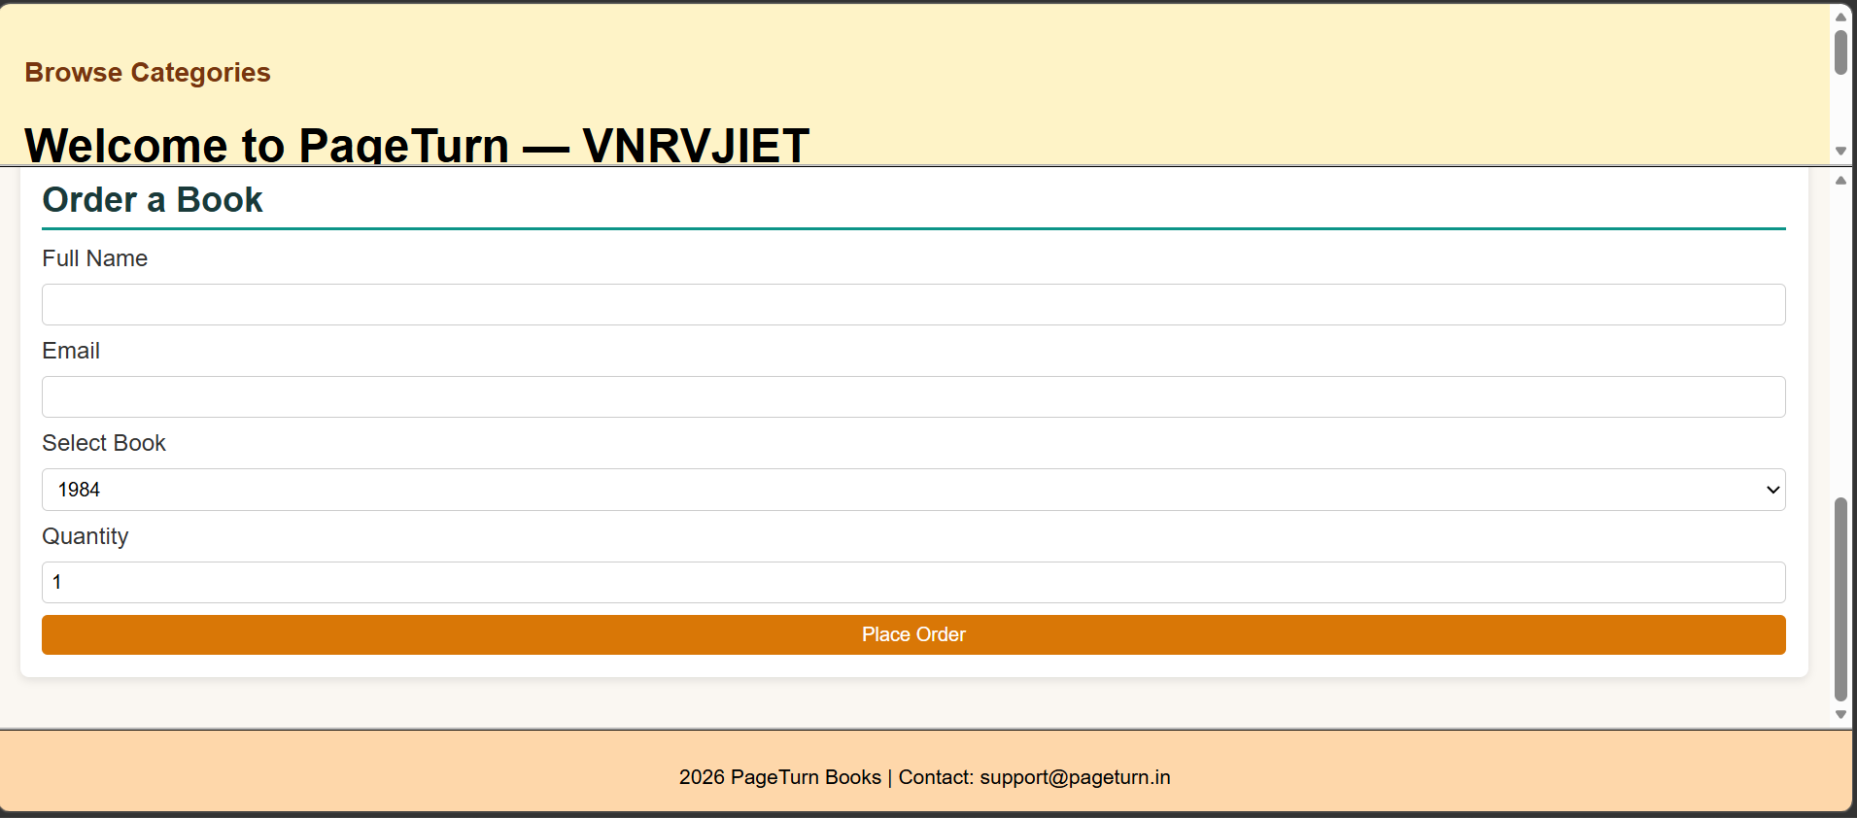

WEEK-3:
JavaScript:
a) User Registration Form
Create a registration form for users signing up on the online bookstore. Validate
the following:
• Username: Should not be empty and must be at least 5 characters long.
• Password: Should not be empty and must be at least 8 characters long.
• Confirm Password: Should match the entered password.
b) Forgot Password Form
Implement a form for users to reset their password. Validate the following:
• Email Address: Should be a valid email format.
• Provide feedback if the email address is not associated with any account.
c) Dynamically Content Loading
Use JavaScript to dynamically load book details into the content frame when a user
clicks on a book in the navigation frame.

Week3.html:
<!DOCTYPE html>
<html>
<head>
<title>Online Book Store - Week 3</title>
</head>
<frameset rows="20%,70%,10%" border="2">
<frame src="navigation.html" name="navFrame">
<frame src="content.html" name="contentFrame">
<frame src="footer.html" name="footerFrame">
</frameset>
</html>
Week3.js:
// week3.js - Dynamically load book details into the content frame

document.addEventListener('DOMContentLoaded', function () {
// This script runs inside the navigation frame (navigation.html)
var navLinks = document.querySelectorAll('a[data-book-id]');
if (!navLinks.length) {
return;
}

var bookData = {
'clean-code': {
title: 'Clean Code',
author: 'Robert C. Martin',
category: 'Technology / Programming',
price: '$20',
isbn: '978-0132350884',
availability: 'In Stock',
description: 'A handbook of agile software craftsmanship focusing on writing clean, maintainable code.'
},
'alchemist': {
title: 'The Alchemist',
author: 'Paulo Coelho',
category: 'Fiction',
price: '$12',
isbn: '978-0061122415',
availability: 'In Stock',
description: 'A novel about a shepherd boy on a journey to realize his personal legend.'
},
'atomic-habits': {
title: 'Atomic Habits',
author: 'James Clear',
category: 'Self Help',
price: '$15',
isbn: '978-0735211292',
availability: 'Limited Stock',
description: 'Practical strategies for building good habits and breaking bad ones.'
},
'ds-algo': {
title: 'Data Structures and Algorithms',
author: 'Narasimha Karumanchi',
category: 'Computer Science',
price: '$25',
isbn: '978-8193245279',
availability: 'Out of Stock',
description: 'Detailed explanations of core data structures and algorithms with interview focus.'
}
};

function loadBookIntoContentFrame(bookId) {
var info = bookData[bookId];
if (!info) {
return;
}

var contentFrame = parent.frames['contentFrame'];
if (!contentFrame || !contentFrame.document) {
return;
}

var doc = contentFrame.document;
var container = doc.getElementById('bookDetails');
if (!container) {
return;
}

container.innerHTML =
'<h3>' + info.title + '</h3>' +
'<p><strong>Author:</strong> ' + info.author + '</p>' +
'<p><strong>Category:</strong> ' + info.category + '</p>' +
'<p><strong>ISBN:</strong> ' + info.isbn + '</p>' +
'<p><strong>Price:</strong> ' + info.price + '</p>' +
'<p><strong>Availability:</strong> ' + info.availability + '</p>' +
'<p><strong>Description:</strong> ' + info.description + '</p>';
}

navLinks.forEach(function (link) {
link.addEventListener('click', function (e) {
e.preventDefault();
var bookId = this.getAttribute('data-book-id');
loadBookIntoContentFrame(bookId);
});
});
});
Registration.html:
<!DOCTYPE html>
<html lang="en">
<head>
<meta charset="UTF-8">
<meta name="viewport" content="width=device-width, initial-scale=1.0">
<title>User Registration - Online Bookstore</title>
<link rel="stylesheet" href="registration.css">
</head>
<body>
<div class="container">
<h2>User Registration</h2>
<form id="registrationForm" autocomplete="off">
<label for="username">Username:</label>
<input type="text" id="username" name="username" required>

<label for="password">Password:</label>
<input type="password" id="password" name="password" required>

<label for="confirmPassword">Confirm Password:</label>
<input type="password" id="confirmPassword" name="confirmPassword" required>

<div id="errorMsg" class="error" style="display:none;"></div>
<button type="submit">Register</button>
<div style="text-align:center; margin-top:15px;">
<a href="forgotpassword.html">Forgot Password?</a>
</div>
</form>
</div>
<script src="registration.js"></script>
</body>
</html>
ForgotPassword.html:
<!DOCTYPE html>
<html lang="en">
<head>
<meta charset="UTF-8">
<meta name="viewport" content="width=device-width, initial-scale=1.0">
<title>Forgot Password - Online Bookstore</title>
<link rel="stylesheet" href="forgotpassword.css">
</head>
<body>
<div class="container">
<h2>Forgot Password</h2>
<form id="forgotPasswordForm" autocomplete="off">
<label for="email">Email Address:</label>
<input type="email" id="email" name="email" required>
<div id="fpErrorMsg" class="error" style="display:none;"></div>
<button type="submit">Reset Password</button>
</form>
</div>
<script src="forgotpassword.js"></script>
</body>
</html>
Forgotpassword.js:

document.addEventListener('DOMContentLoaded', function() {
var form = document.getElementById('forgotPasswordForm');
if (!form) return;
form.addEventListener('submit', function(e) {
e.preventDefault();
var email = document.getElementById('email').value.trim();
var errorMsg = document.getElementById('fpErrorMsg');
errorMsg.style.display = 'none';
errorMsg.innerText = '';

var emailRegex = /^[\w-\.]+@([\w-]+\.)+[\w-]{2,4}$/;
if (!emailRegex.test(email)) {
errorMsg.innerText = 'Please enter a valid email address.';
errorMsg.style.display = 'block';
return;
}

// Simulated check for email association (for demo, only these emails are valid)
var validEmails = ['user1@example.com', 'user2@example.com', 'test@bookstore.com','pranav.tungani@gmail.com'];
if (!validEmails.includes(email)) {
errorMsg.innerText = 'This email address is not associated with any account.';
errorMsg.style.display = 'block';
return;
}

alert('A password reset link has been sent to your email.');
form.reset();
});
});
Registration.js:
// registration.js - Security and validation for registration form

document.addEventListener('DOMContentLoaded', function() {
var form = document.getElementById('registrationForm');
if (!form) return;
form.addEventListener('submit', function(e) {
e.preventDefault();
var username = document.getElementById('username').value.trim();
var password = document.getElementById('password').value;
var confirmPassword = document.getElementById('confirmPassword').value;
var errorMsg = document.getElementById('errorMsg');
errorMsg.style.display = 'none';
errorMsg.innerText = '';

// Username validation
if (username.length < 5) {
errorMsg.innerText = 'Username must be at least 5 characters long.';
errorMsg.style.display = 'block';
return;
}
// Password validation
if (password.length < 8) {
errorMsg.innerText = 'Password must be at least 8 characters long.';
errorMsg.style.display = 'block';
return;
}
// Password strength (at least 1 uppercase, 1 lowercase, 1 number)
var strongRegex = /^(?=.*[a-z])(?=.*[A-Z])(?=.*\d).+$/;
if (!strongRegex.test(password)) {
errorMsg.innerText = 'Password must contain uppercase, lowercase, and a number.';
errorMsg.style.display = 'block';
return;
}
// Confirm password
if (password !== confirmPassword) {
errorMsg.innerText = 'Passwords do not match.';
errorMsg.style.display = 'block';
return;
}
// All validations passed
alert('Registration successful!');
form.reset();

// Navigate to the content page after successful registration
window.location.href = 'navigation.html';
});
});
Webpage:
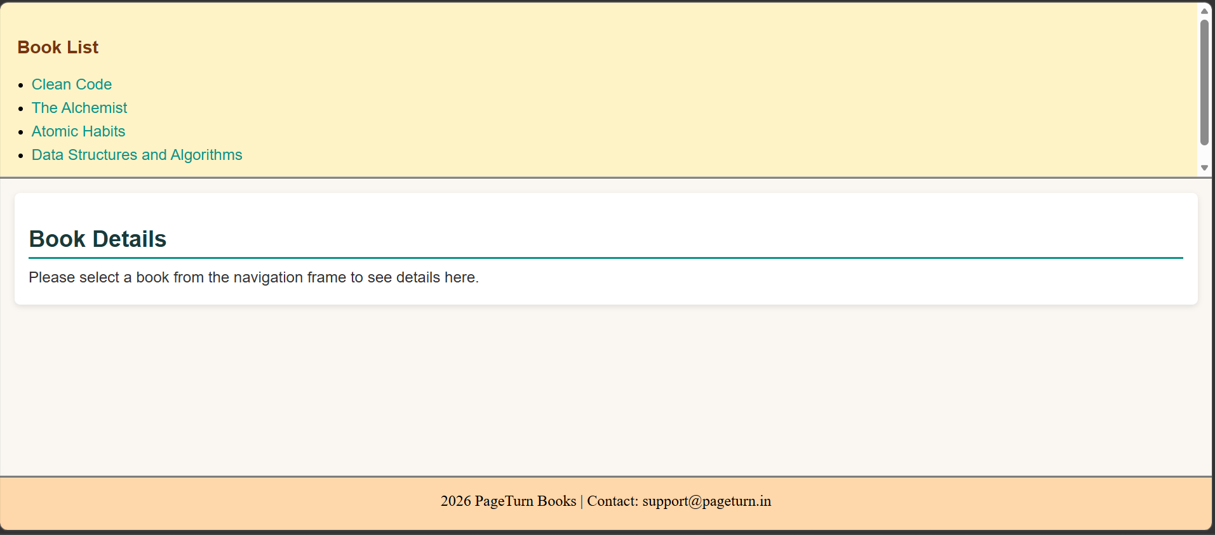

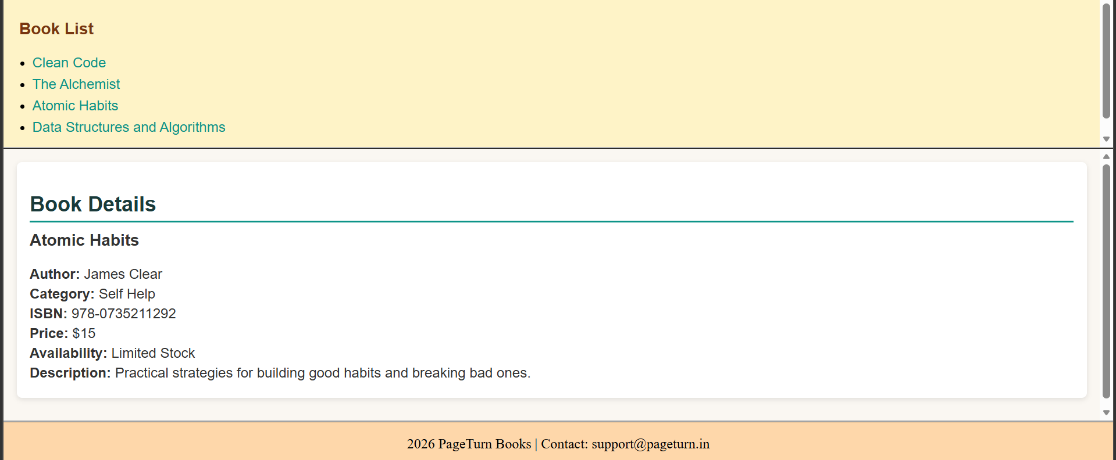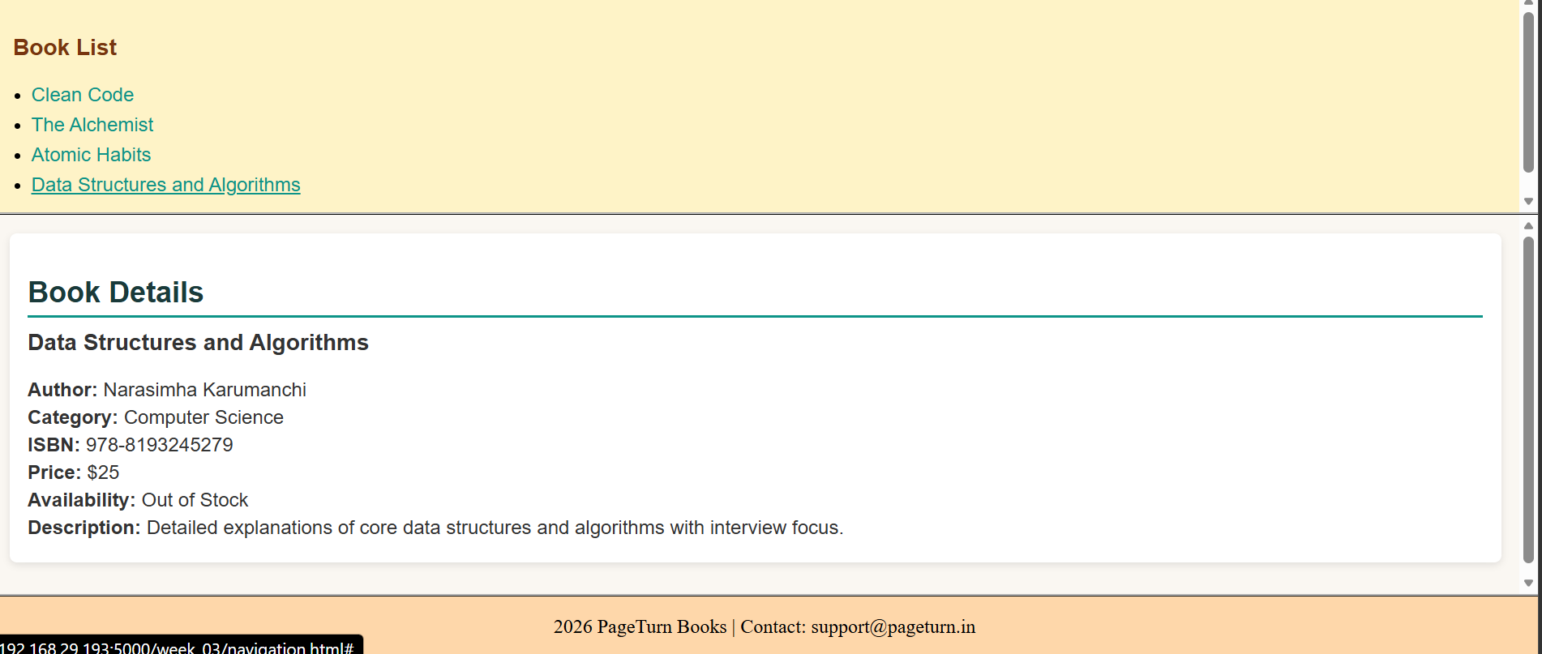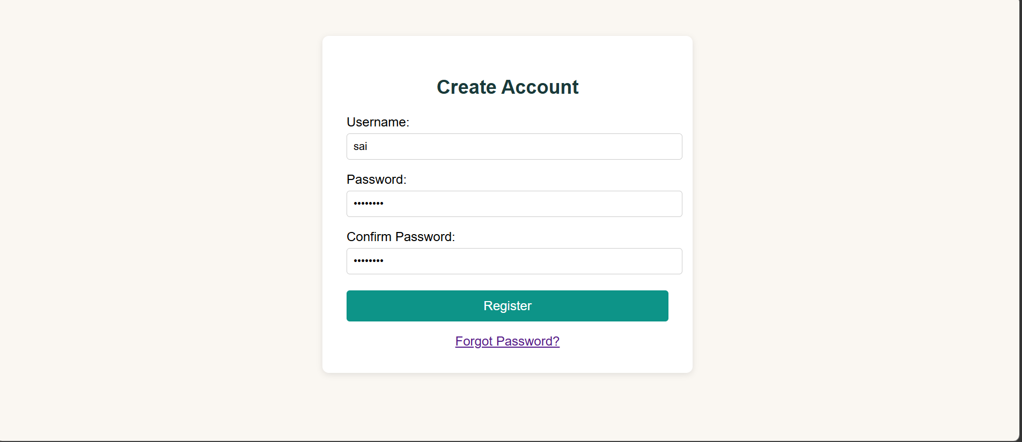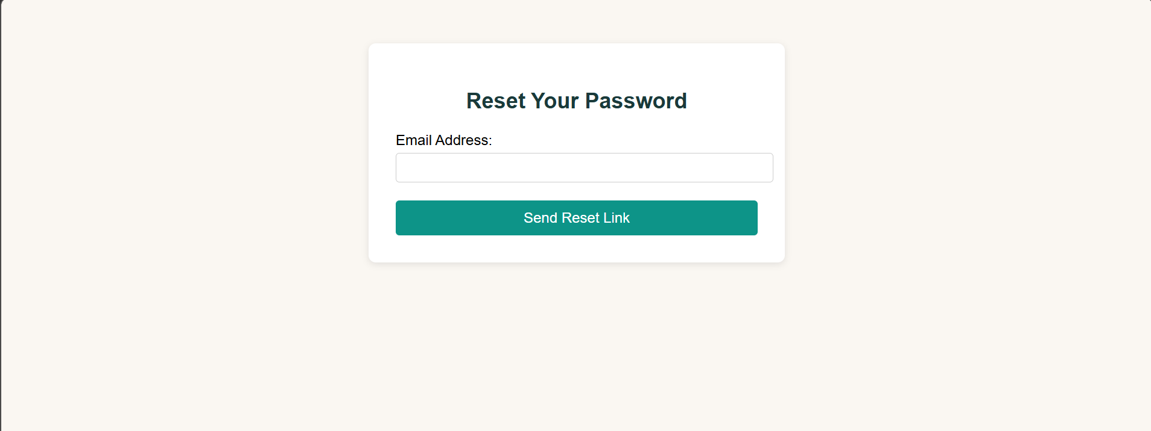

WEEK-4: Shopping Cart Functionality: Implement a simple shopping cart using JavaScript. Allow users to add books to their cart and view the cart's contents.

Cart.html:
<!DOCTYPE html>
<html lang="en">
<head>
<meta charset="UTF-8">
<title>My Cart</title>
<link rel="stylesheet" href="styles.css">
</head>
<body>
<main>
<h1>My Cart</h1>
<a href="index.html">Back to Store</a>

<div id="cart-items"></div>
<p><strong>Total: Rs. <span id="total">0</span></strong></p>
<button onclick="clearCart()">Clear Cart</button>
</main>

<script src="script.js"></script>
</body>
</html>
Index.html:
<!DOCTYPE html>
<html lang="en">
<head>
<meta charset="UTF-8">
<title>Book Store</title>
<link rel="stylesheet" href="styles.css">
</head>
<body>
<main>
<h1>Book Store</h1>
<a href="cart.html">View Cart (<span id="cart-count">0</span>)</a>

<div id="books">
<div class="book">
<h3>The Alchemist</h3>
<p>By Paulo Coelho</p>
<p>Price: Rs. 299</p>
<button onclick="addToCart('The Alchemist', 299)">Add to Cart</button>
</div>

<div class="book">
<h3>Atomic Habits</h3>

<p>By James Clear</p>
<p>Price: Rs. 499</p>
<button onclick="addToCart('Atomic Habits', 499)">Add to Cart</button>
</div>

<div class="book">
<h3>Rich Dad Poor Dad</h3>
<p>By Robert Kiyosaki</p>
<p>Price: Rs. 349</p>
<button onclick="addToCart('Rich Dad Poor Dad', 349)">Add to Cart</button>
</div>

<div class="book">
<h3>Deep Work</h3>
<p>By Cal Newport</p>
<p>Price: Rs. 399</p>
<button onclick="addToCart('Deep Work', 399)">Add to Cart</button>
</div>
</div>
</main>

<script src="script.js"></script>
</body>
</html>
Script.js:
// Get cart from localStorage (or empty array)
function getCart() {
return JSON.parse(localStorage.getItem('cart')) || [];
}

// Save cart to localStorage
function saveCart(cart) {
localStorage.setItem('cart', JSON.stringify(cart));
}

// Add a book to the cart
function addToCart(title, price) {
var cart = getCart();
cart.push({ title: title, price: price });
saveCart(cart);
alert(title + ' added to cart!');
updateCount();
}

// Update the cart count shown on the store page
function updateCount() {
var countEl = document.getElementById('cart-count');
if (countEl) {
countEl.textContent = getCart().length;
}
}

// Show cart items on cart.html
function showCart() {
var cart = getCart();
var container = document.getElementById('cart-items');
if (!container) return;

if (cart.length === 0) {
container.innerHTML = '<p>Your cart is empty.</p>';
document.getElementById('total').textContent = 0;
return;
}

var html = '<ul>';
var total = 0;
for (var i = 0; i < cart.length; i++) {
html += '<li>' + cart[i].title + ' - Rs. ' + cart[i].price + '</li>';
total += cart[i].price;
}
html += '</ul>';
container.innerHTML = html;
document.getElementById('total').textContent = total;
}

// Clear all items from cart
function clearCart() {
localStorage.removeItem('cart');
showCart();
}

// Run on page load
updateCount();
showCart();
Styles.css:
body {
font-family: Arial, sans-serif;
margin: 0;
padding: 0;
background: #f5f7fb;
}
/* Books grid */
#books{
display: flex;
flex-wrap: wrap;
gap: 18px;
justify-content: center;
}

.book {
background: #ffffff;
border-radius: 10px;
box-shadow: 0 2px 8px rgba(11,37,69,0.06);
padding: 16px;
width: 240px;
display: flex;
flex-direction: column;
gap: 8px;
transition: transform 160ms ease, box-shadow 160ms ease;
}

.book:hover {
transform: translateY(-6px);
box-shadow: 0 10px 22px rgba(11,37,69,0.10);
}

.book h3 { margin: 0; font-size: 1.05rem; color: #071b2d; }
.book p { margin: 0; color: #475569; font-size: 0.9rem; }
.book .price { font-weight: 700; color: #111827; }

button {
padding: 10px 14px;
background-color: #0b74de;
color: white;
border: none;
border-radius: 8px;
cursor: pointer;
align-self: start;
transition: background-color 120ms ease, transform 120ms ease;
}

button:hover { background-color: #075fae; transform: translateY(-2px); }
button:active { transform: translateY(0); }

/* Cart link badge */
#cart-count {
background: #ef4444;
color: #fff;
padding: 2px 8px;
border-radius: 999px;
margin-left: 6px;
font-weight: 700;
font-size: 0.85rem;
}

/* Cart page styles */
#cart-items { margin: 18px 0; }
.cart-item {
display: flex;
justify-content: space-between;
align-items: center;
padding: 10px 12px;
background: #fff;
border-radius: 8px;
box-shadow: 0 1px 4px rgba(11,37,69,0.04);
margin-bottom: 10px;
}

.cart-item .name { font-weight: 600; }
.cart-item .price { color: #0b2545; font-weight: 700; }

/* Responsive */
@media (max-width: 600px) {
main { margin: 18px; padding: 12px; }
.book { width: 100%; max-width: 420px; }
}

/* Small utility */
.muted { color: #6b7280; font-size: 0.9rem; }

/* Style cart list rendered by script.js */
#cart-items ul { list-style: none; padding: 0; margin: 0; }
#cart-items ul li {
padding: 10px 12px;
background: #fff;
border-radius: 8px;
box-shadow: 0 1px 4px rgba(11,37,69,0.04);
margin-bottom: 10px;
display: flex;
justify-content: space-between;
align-items: center;
}
#cart-items ul li::after { content: attr(data-price); font-weight:700; color:#0b2545; }
WEBPAGE:
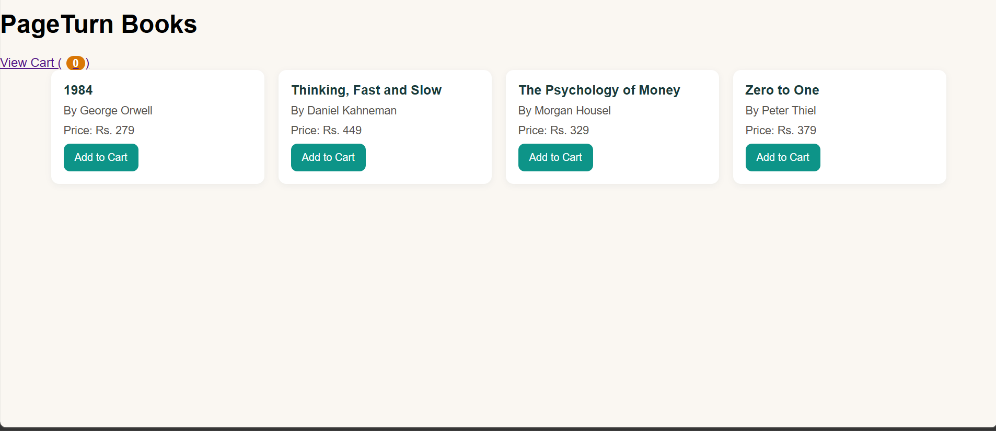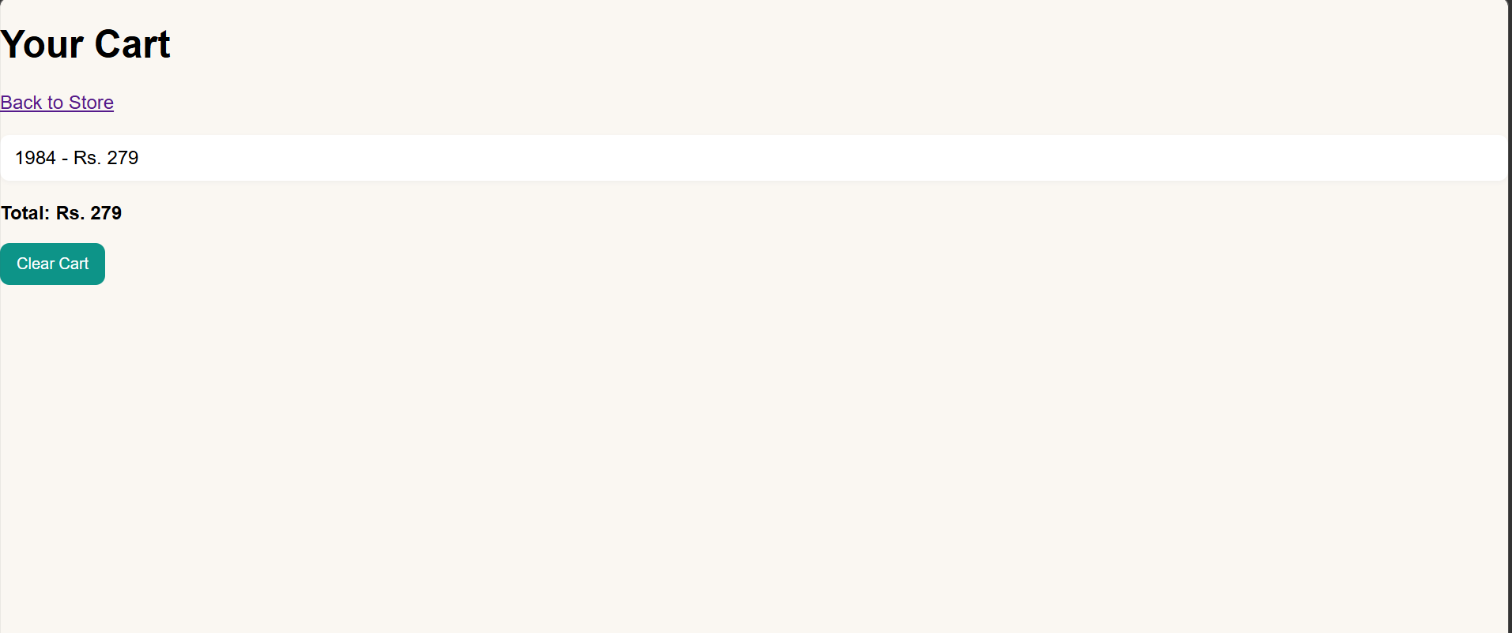
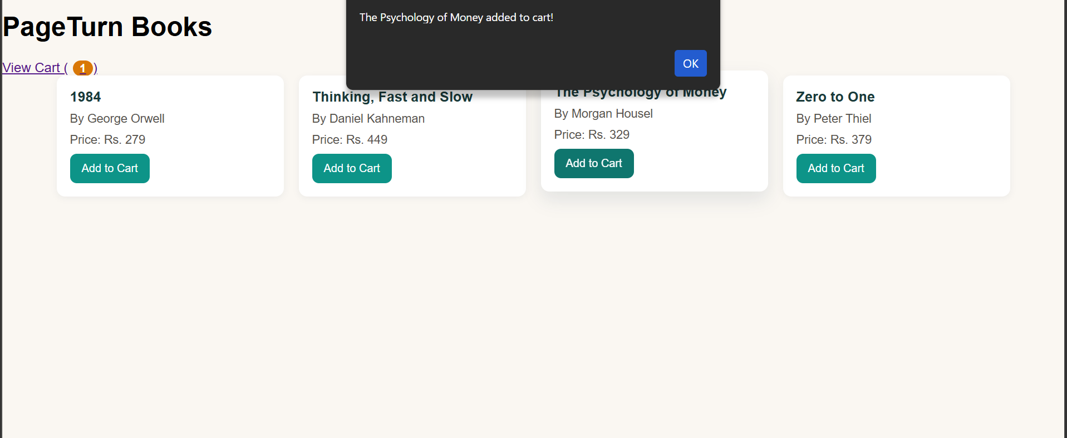

WEEK-5: XML Structure and Design: Book Catalog XML: Design an XML structure to represent the catalog of books in the online store. Include details such as book title, author, genre, price, and availability.

Book_catalog_view.html:
<!doctype html>
<html lang="en">
<head>
<meta charset="utf-8">
<meta name="viewport" content="width=device-width,initial-scale=1">
<title>Book Catalog Viewer</title>
<link rel="stylesheet" href="book_catalog.css">
</head>
<body>
<header class="site-header">
<h1>Book Catalog</h1>
</header>

<main class="container">
<div class="controls">
<input id="search" placeholder="Search by title, author, or genre" />
<select id="genreFilter"><option value="">All genres</option></select>
<button id="refresh">Refresh</button>
</div>

<div id="catalog" class="grid" aria-live="polite"></div>
</main>

<script src="book_catalog.js"></script>
</body>
</html>
Book_catalog.css:
:root {
--bg: #f5f3ff;
--card: #ffffff;
--muted: #6b7280;
--accent: #7c3aed;
--success: #10b981;
--danger: #ef4444;
--glass: rgba(255, 255, 255, 0.6);
}
* {
box-sizing: border-box;
}
body {
font-family:
Segoe UI,
Roboto,
Arial,
sans-serif;
margin: 0;
background: var(--bg);
color: #1e1b4b;
}
.site-header {
background: linear-gradient(90deg, var(--accent), #db2777);
color: white;
padding: 20px 24px;
}
.site-header h1 {
margin: 0;
font-size: 1.25rem;
}
.container {
max-width: 1100px;
margin: 24px auto;
padding: 0 16px;
}
.controls {
display: flex;
gap: 10px;
align-items: center;
margin-bottom: 18px;
}
.controls input,
.controls select {
padding: 10px 12px;
font-size: 0.95rem;
border: 1px solid #e6e9ee;
border-radius: 8px;
min-width: 0;
}
.controls button {
padding: 10px 14px;
border-radius: 8px;
background: var(--accent);
color: white;
border: none;
cursor: pointer;
}
.grid {
display: grid;
grid-template-columns: repeat(auto-fill, minmax(220px, 1fr));
gap: 16px;
}
.card {
background: var(--card);
padding: 14px;
border-radius: 12px;
box-shadow: 0 6px 20px rgba(20, 20, 40, 0.06);
display: flex;
flex-direction: column;
gap: 8px;
}
.title {
font-weight: 700;
font-size: 1.02rem;
}
.author {
color: var(--muted);
font-size: 0.92rem;
}
.meta {
display: flex;
justify-content: space-between;
align-items: center;
margin-top: 6px;
}
.genre {
font-size: 0.85rem;
padding: 6px 8px;
border-radius: 999px;
background: var(--glass);
color: #374151;
}
.price {
font-weight: 700;
color: var(--accent);
}
.availability {
font-size: 0.85rem;
padding: 6px 8px;
border-radius: 999px;
}
.availability.in-stock {
background: rgba(16, 185, 129, 0.08);
color: var(--success);
border: 1px solid rgba(16, 185, 129, 0.12);
}
.availability.out-of-stock {
background: rgba(239, 68, 68, 0.08);
color: var(--danger);
border: 1px solid rgba(239, 68, 68, 0.12);
}
.empty {
padding: 30px;
text-align: center;
color: var(--muted);
}
@media (max-width: 520px) {
.controls {
flex-direction: column;
align-items: stretch;
}
.controls input {
width: 100%;
}
}

Book_catalog.js:
async function loadCatalog(){
try{
const res = await fetch('book_catalog.xml');
if(!res.ok) throw new Error('Failed to load XML');
const text = await res.text();
const parser = new DOMParser();
const xml = parser.parseFromString(text, 'application/xml');

const books = Array.from(xml.getElementsByTagName('book')).map(b => {
const title = b.getElementsByTagName('title')[0]?.textContent || '';
const author = b.getElementsByTagName('author')[0]?.textContent || '';
const genre = b.getElementsByTagName('genre')[0]?.textContent || '';
const priceEl = b.getElementsByTagName('price')[0];
const price = priceEl?.textContent || '';
const currency = priceEl?.getAttribute('currency') || '';
const availEl = b.getElementsByTagName('availability')[0];
const availabilityCount = availEl?.textContent || '0';
const status = availEl?.getAttribute('status') || (Number(availabilityCount)>0 ? 'in-stock' : 'out-of-stock');
return { id: b.getAttribute('id'), title, author, genre, price, currency, availabilityCount: Number(availabilityCount), status };
});

return books;
}catch(err){
console.error(err);
return null;
}
}

function renderBooks(books){
const container = document.getElementById('catalog');
container.innerHTML = '';
if(!books || books.length===0){
container.innerHTML = '<div class="empty">No books found.</div>';
return;
}

const frag = document.createDocumentFragment();
books.forEach(b=>{
const card = document.createElement('article');
card.className = 'card';
card.innerHTML = `
<div class="title">${escapeHtml(b.title)}</div>
<div class="author">by ${escapeHtml(b.author)}</div>
<div class="meta">
<div class="genre">${escapeHtml(b.genre)}</div>
<div class="price">${escapeHtml(b.currency)} ${escapeHtml(b.price)}</div>
</div>
<div style="display:flex;justify-content:space-between;align-items:center">
<div class="availability ${b.status === 'in-stock' ? 'in-stock' : 'out-of-stock'}">${b.status === 'in-stock' ? 'In stock' : 'Out of stock'}</div>
<div style="color:var(--muted);font-size:0.85rem">Qty: ${b.availabilityCount}</div>
</div>
`;
frag.appendChild(card);
});
container.appendChild(frag);
}

function escapeHtml(s){
return String(s).replaceAll('&','&amp;').replaceAll('<','&lt;').replaceAll('>','&gt;');
}

function applyFilters(allBooks){
const q = document.getElementById('search').value.trim().toLowerCase();
const genre = document.getElementById('genreFilter').value;
let filtered = allBooks.filter(b => {
const hay = `${b.title} ${b.author} ${b.genre}`.toLowerCase();
return hay.includes(q) && (genre === '' || b.genre === genre);
});
renderBooks(filtered);
}

(async function init(){
const allBooks = await loadCatalog();
if(allBooks === null){
document.getElementById('catalog').innerHTML = '<div class="empty">Could not load catalog. Make sure <code>book_catalog.xml</code> is next to the viewer.</div>';
return;
}

// populate genre filter
const genres = Array.from(new Set(allBooks.map(b=>b.genre).filter(Boolean))).sort();
const select = document.getElementById('genreFilter');
genres.forEach(g=>{
const opt = document.createElement('option');
opt.value = g; opt.textContent = g; select.appendChild(opt);
});

// initial render
renderBooks(allBooks);

// wire controls
document.getElementById('search').addEventListener('input', ()=>applyFilters(allBooks));
select.addEventListener('change', ()=>applyFilters(allBooks));
document.getElementById('refresh').addEventListener('click', async ()=>{
const refreshed = await loadCatalog();
if(refreshed) {
allBooks.length = 0; allBooks.push(...refreshed);
applyFilters(allBooks);
}
});
})();

Book_catalog.xml:
<?xml version="1.0" encoding="UTF-8"?>
<catalog>
<book id="B001">
<title>The Great Gatsby</title>
<author>F. Scott Fitzgerald</author>
<genre>Fiction</genre>
<price currency="USD">10.99</price>
<availability status="in-stock">15</availability>
</book>

<book id="B002">
<title>A Brief History of Time</title>
<author>Stephen Hawking</author>
<genre>Science</genre>
<price currency="USD">15.50</price>
<availability status="in-stock">8</availability>
</book>

<book id="B003">
<title>Clean Code</title>
<author>Robert C. Martin</author>
<genre>Technology</genre>
<price currency="USD">32.00</price>
<availability status="in-stock">23</availability>
</book>

<book id="B004">
<title>To Kill a Mockingbird</title>
<author>Harper Lee</author>
<genre>Fiction</genre>
<price currency="USD">12.99</price>
<availability status="out-of-stock">0</availability>
</book>

<book id="B005">
<title>Sapiens: A Brief History of Humankind</title>
<author>Yuval Noah Harari</author>
<genre>History</genre>
<price currency="USD">18.75</price>
<availability status="in-stock">5</availability>
</book>
</catalog>

WEBPAGE:
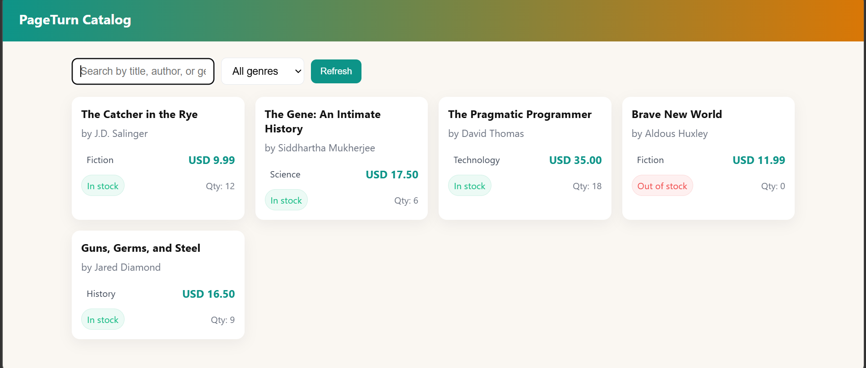
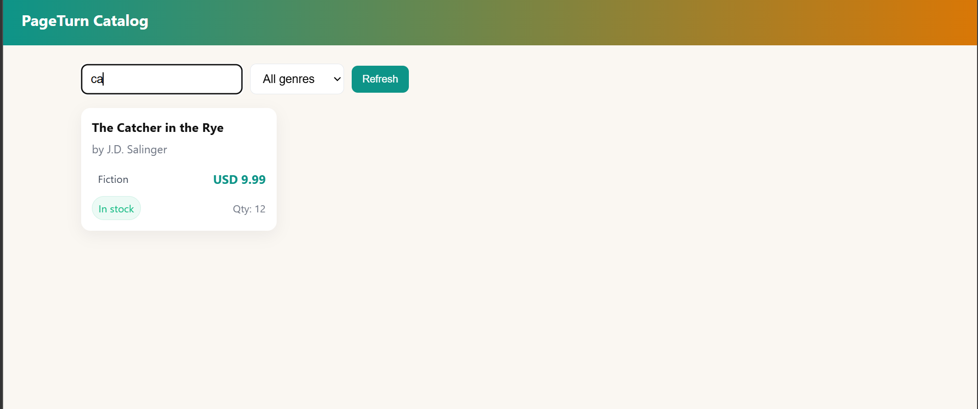

WEEK-6: User Account XML: Create an XML structure to store user account information, including details like username, password (encrypted), email, and purchase history.

1.The XML File (users.xml)

<?xml version="1.0" encoding="UTF-8"?>
<userAccounts>
<user id="u1">
<username>alice_smith</username> <password>5e884898da28047151d0e56f8dc6292773603d0d6aabbdd62a11ef721d1542d8</password>
<email>alice@example.com</email>
<purchaseHistory>
<purchase>
<itemName>Wireless Keyboard</itemName>
<price>$45.00</price>
<date>2026-03-15</date>
</purchase>
<purchase>
<itemName>USB-C Hub</itemName>
<price>$25.00</price>
<date>2026-04-02</date>
</purchase>
</purchaseHistory>
</user>
<user id="u2">
<username>bob_jones</username> <password>8d969eef6ecad3c29a3a629280e686cf0c3f5d5a86aff3ca12020c923adc6c92</password>
<email>bob.j@example.com</email>
<purchaseHistory>
<purchase>
<itemName>Ergonomic Mouse</itemName>
<price>$60.00</price>
<date>2026-04-05</date>
</purchase>
</purchaseHistory>
</user>
</userAccounts>

2. Page 1: User Directory (index.html)

<!DOCTYPE html>
<html lang="en">
<head>
<meta charset="UTF-8">
<title>User Directory</title>
<style>
body { font-family: Arial, sans-serif; padding: 20px; background: #f4f4f9; }
.user-card { background: white; padding: 15px; margin-bottom: 10px; border-radius: 5px; box-shadow: 0 2px 4px rgba(0,0,0,0.1); }
a { text-decoration: none; color: white; background: #007bff; padding: 5px 10px; border-radius: 3px; font-size: 14px; }
</style>
</head>
<body>

<h2>User Accounts Dashboard</h2>
<div id="users-container">Loading users...</div>

<script>
fetch('users.xml')
.then(response => response.text())
.then(data => {
const parser = new DOMParser();
const xml = parser.parseFromString(data, "application/xml");
const users = xml.querySelectorAll('user');
let output = '';

users.forEach(user => {
const id = user.getAttribute('id');
const username = user.querySelector('username').textContent;
const email = user.querySelector('email').textContent;

output += `
<div class="user-card">
<h3>${username}</h3>
<p>Email: ${email}</p>
<a href="history.html?id=${id}">View Purchase History</a>
</div>
`;
});
document.getElementById('users-container').innerHTML = output;
});
</script>
</body>
</html>

3. Page 2: Purchase History (history.html)

<!DOCTYPE html>
<html lang="en">
<head>
<meta charset="UTF-8">
<title>Purchase History</title>
<style>
body { font-family: Arial, sans-serif; padding: 20px; background: #f4f4f9; }
.purchase { background: white; padding: 10px; margin-bottom: 5px; border-left: 4px solid #28a745; }
a.back { display: inline-block; margin-bottom: 15px; color: #007bff; text-decoration: none; }
</style>
</head>
<body>

<a href="index.html" class="back">← Back to Directory</a>
<h2 id="user-title">Purchase History</h2>
<div id="history-container">Loading...</div>

<script>
// Get the user ID from the URL (e.g., ?id=u1)
const params = new URLSearchParams(window.location.search);
const userId = params.get('id');

fetch('users.xml')
.then(response => response.text())
.then(data => {
const parser = new DOMParser();
const xml = parser.parseFromString(data, "application/xml");

// Find the specific user by ID
const user = xml.querySelector(`user[id="${userId}"]`);

if (!user) {
document.getElementById('history-container').innerHTML = "<p>User not found.</p>";
return;
}

const username = user.querySelector('username').textContent;
document.getElementById('user-title').textContent =`Purchase History for ${username}`;
const purchases = user.querySelectorAll('purchaseHistory purchase');
let output = '';

if (purchases.length === 0) {
output = "<p>No purchases found.</p>";
} else {
purchases.forEach(p => {
const item = p.querySelector('itemName').textContent;
const price = p.querySelector('price').textContent;
const date = p.querySelector('date').textContent;

output += `
<div class="purchase">
<strong>${item}</strong> - ${price} <br>
<small>Purchased on: ${date}</small>
</div>
`;
});
}
document.getElementById('history-container').innerHTML = output;
});
</script>
</body>
</html>

OUTPUT

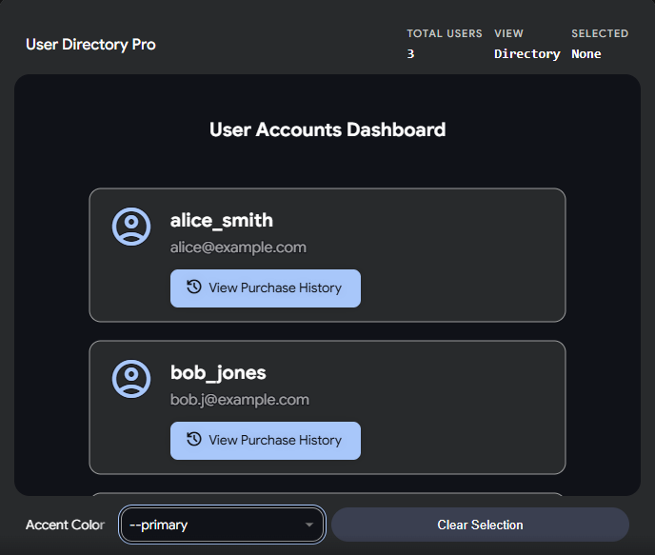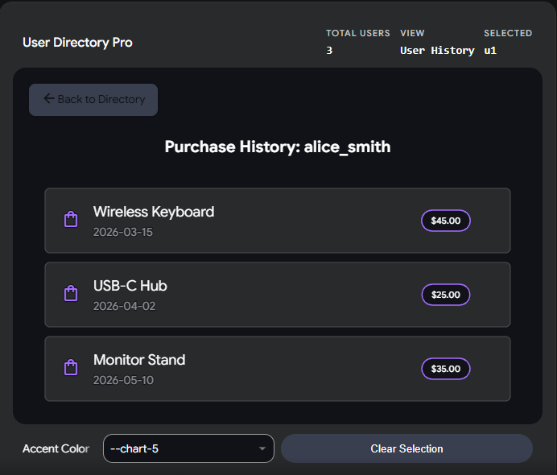

WEEK-7: Install and configure Apache Tomcat server in Eclipse

Step 1: Install Apache Tomcat (outside Eclipse)

Step 2: Open Eclipse in Java EE Perspective

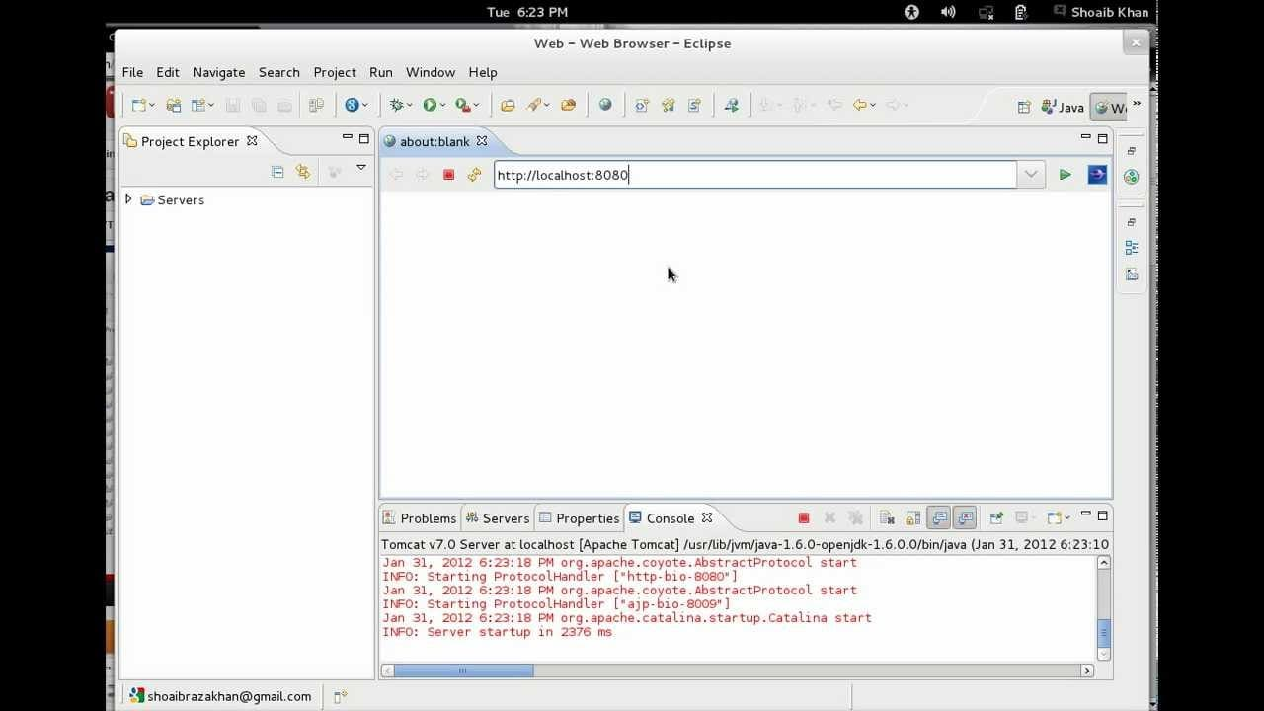

Step 3: Add Tomcat Server Runtime

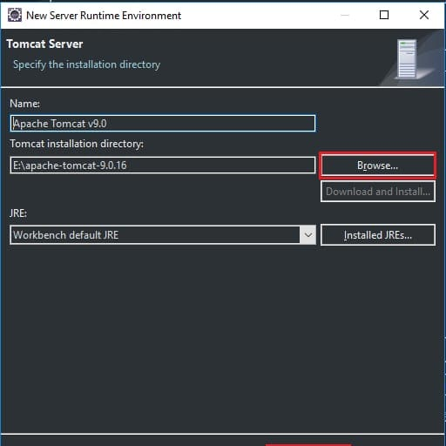

Step 4: Create a Tomcat Server in Eclipse

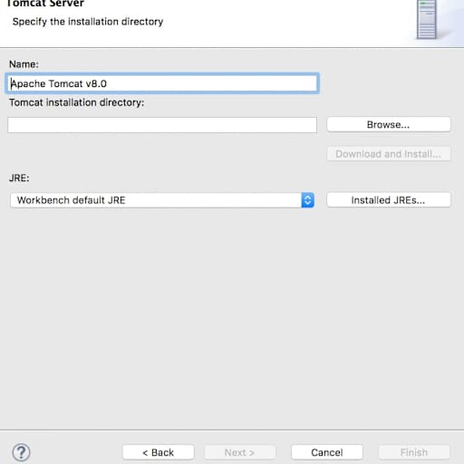

Step 5: Start the Tomcat Server

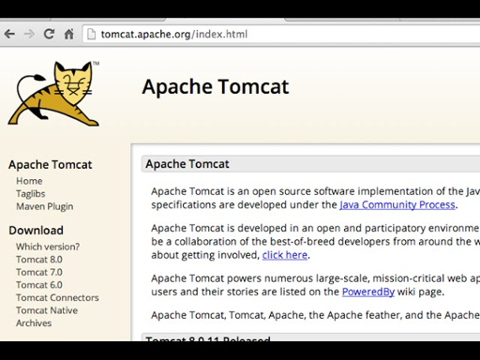

Step 6: Create a Simple Web Project and Deploy on Tomcat

Step 7: Verify Everything is Working

WEEK-8: Servlet for Book Retrieval: Develop a servlet that retrieves book information from a database and sends it to the content frame.

1.Database Setup (SQL)

CREATE TABLE books (
id INT PRIMARY KEY,
title VARCHAR(100),
author VARCHAR(100),
year INT
);

INSERT INTO books VALUES (1, 'Clean Code', 'Robert C. Martin', 2008);
INSERT INTO books VALUES (2, 'The Pragmatic Programmer', 'Andrew Hunt', 1999);
INSERT INTO books VALUES (3, 'Design Patterns', 'Erich Gamma', 1994);

2. Main Layout (index.html)

<!DOCTYPE html>
<html>
<head>
<title>Book Library</title>
</head>
<frameset cols="20%, 80%">
<frame src="nav.html" name="navFrame">
<frame src="content.html" name="contentFrame">
</frameset>
</html>

3. Navigation Frame (nav.html)

<!DOCTYPE html>
<html>
<body style="font-family: Arial, sans-serif; background-color: #f4f4f4;">
<h3>Menu</h3>
<a href="BookServlet" target="contentFrame">View All Books</a>
</body>
</html>

4. The Servlet (BookServlet.java)

import java.io.*;
import java.sql.*;
import javax.servlet.*;
import javax.servlet.http.*;
public class BookServlet extends HttpServlet {
public void doGet(HttpServletRequest request, HttpServletResponse response)
throws ServletException, IOException {
response.setContentType("text/html");
PrintWriter out = response.getWriter();
out.println("<html><head><style>table {width: 100%; border-collapse: collapse;} th, td {border: 1px solid black; padding: 8px; text-align: left;} th {background-color: #f2f2f2;}</style></head><body>");
out.println("<h2>Book List</h2>
try {
// 1. Load Driver (Example for MySQL)
Class.forName("com.mysql.cj.jdbc.Driver");

// 2. Connect to DB (Change URL, username, password!)
Connection con = DriverManager.getConnection("jdbc:mysql://localhost:3306/yourdb", "root", "password");

// 3. Execute Query
Statement stmt = con.createStatement();
ResultSet rs = stmt.executeQuery("SELECT * FROM books");

// 4. Print HTML Table
out.println("<table><tr><th>ID</th><th>Title</th><th>Author</th><th>Year</th></tr>");
while (rs.next()) {
out.println("<tr>");
out.println("<td>" + rs.getInt("id") + "</td>");
out.println("<td>" + rs.getString("title") + "</td>");
out.println("<td>" + rs.getString("author") + "</td>");
out.println("<td>" + rs.getInt("year") + "</td>");
out.println("</tr>");
}
out.println("</table>");

con.close();
} catch (Exception e) {
out.println("<p>Error: " + e.getMessage() + "</p>");
}

out.println("</body></html>");
}
}

OUTPUT

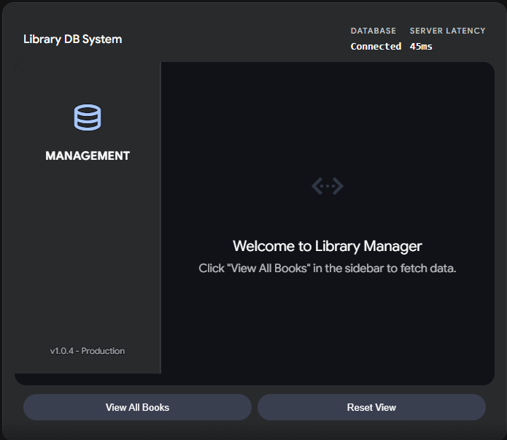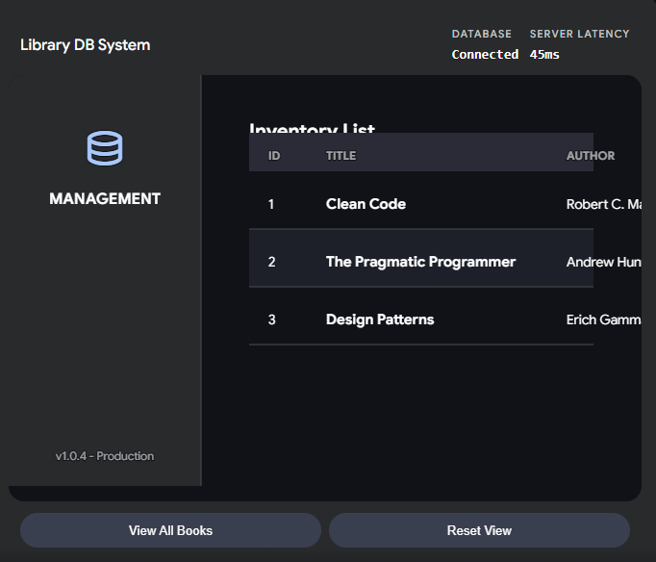

WEEK-9: User Authentication: Implement user authentication using servlets and JSP. Create a login page and restrict access to certain pages for authenticated users.

1.The Login Page (login.jsp)

<%@ page language="java" contentType="text/html; charset=UTF-8" pageEncoding="UTF-8"%>
<!DOCTYPE html>
<html>
<head>
<title>Login</title>
<style>
body { font-family: Arial, sans-serif; background: #f4f4f9; display: flex; justify-content: center; padding-top: 50px; }
.login-box { background: white; padding: 20px; border-radius: 5px; box-shadow: 0 0 10px rgba(0,0,0,0.1); width: 300px; }
input[type="text"], input[type="password"] { width: 90%; padding: 10px; margin: 10px 0; }
button { width: 100%; padding: 10px; background: #007bff; color: white; border: none; cursor: pointer; }
.error { color: red; font-size: 14px; }
</style>
</head>
<body>
<div class="login-box">
<h2>Sign In</h2>
<% if(request.getAttribute("error") != null) { %>
<p class="error"><%= request.getAttribute("error") %></p>
<% } %>
<form action="LoginServlet" method="post">
<input type="text" name="username" placeholder="Username" required><br>
<input type="password" name="password" placeholder="Password" required><br>
<button type="submit">Login</button>
</form>
</div>
</body>
</html>

2. The Authentication Servlet (LoginServlet.java)

import java.io.IOException;
import javax.servlet.ServletException;
import javax.servlet.annotation.WebServlet;
import javax.servlet.http.*;
@WebServlet("/LoginServlet")
public class LoginServlet extends HttpServlet {
protected void doPost(HttpServletRequest request, HttpServletResponse response)
throws ServletException, IOException {
String user = request.getParameter("username");
String pass = request.getParameter("password");
// Hardcoded check (Replace with DB validation in production)
if ("admin".equals(user) && "password123".equals(pass)) {
// Create a session and store the username
HttpSession session = request.getSession();
session.setAttribute("username", user);
// Redirect to the restricted page
response.sendRedirect("dashboard.jsp");
} else {
// Send back to login page with an error
request.setAttribute("error", "Invalid username or password");
request.getRequestDispatcher("login.jsp").forward(request, response);
}
}
}

3. The Restricted Page (dashboard.jsp)

<%@ page language="java" contentType="text/html; charset=UTF-8" pageEncoding="UTF-8"%>
<%
// Security Check: Restrict access to authenticated users only
if (session.getAttribute("username") == null) {
response.sendRedirect("login.jsp");
return; // Stop rendering the page
}
%>
<!DOCTYPE html>
<html>
<head>
<title>Dashboard - Restricted Area</title>
<style>
body { font-family: Arial, sans-serif; padding: 20px; text-align: center; }
.card { background: #e0f7fa; padding: 20px; display: inline-block; border-radius: 8px; }
a.logout { color: white; background: #dc3545; padding: 8px 15px; text-decoration: none; border-radius: 4px; }
</style>
</head>
<body>
<div class="card">
<h2>Welcome, <%= session.getAttribute("username") %>!</h2>
<p>You have successfully accessed the restricted dashboard.</p>
<br>
<a href="LogoutServlet" class="logout">Logout</a>
</div>
</body>
</html>

4. The Logout Servlet (LogoutServlet.java)

import java.io.IOException;
import javax.servlet.ServletException;
import javax.servlet.annotation.WebServlet;
import javax.servlet.http.*;
@WebServlet("/LogoutServlet")
public class LogoutServlet extends HttpServlet {
protected void doGet(HttpServletRequest request, HttpServletResponse response)
throws ServletException, IOException {
HttpSession session = request.getSession(false); // Get existing session
if (session != null) {
session.invalidate(); // Destroy the session
}
response.sendRedirect("login.jsp");
}
}

OUTPUT

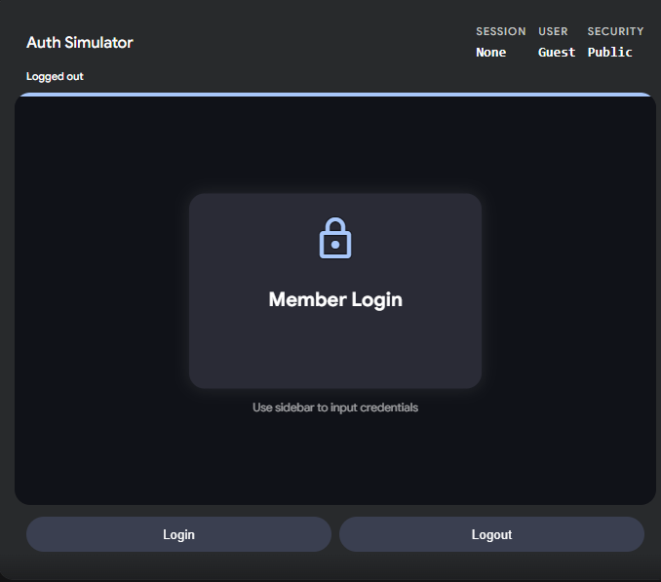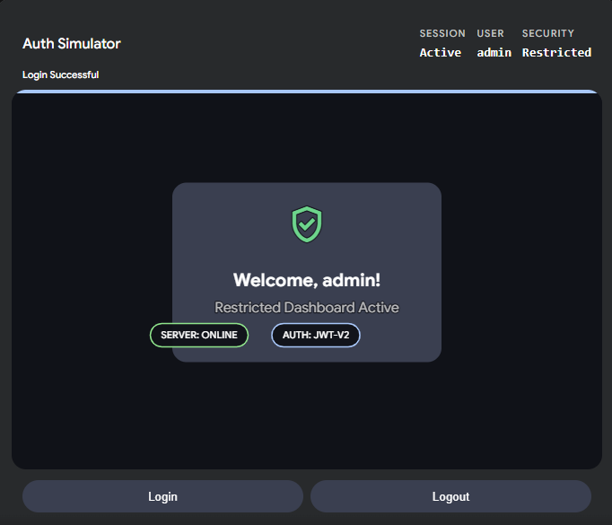

WEEK-10:
Hibernate: Hibernate Entity Mapping: Create Hibernate entity classes to represent
books and users. Map these entities to corresponding database tables

1.The Book Entity (Book.java)

import javax.persistence.*;
@Entity
@Table(name = "books")
public class Book {
@Id // Marks this as the Primary Key
@GeneratedValue(strategy = GenerationType.IDENTITY) // Auto-increments the ID
@Column(name = "book_id")
private int id;
@Column(name = "title", nullable = false, length = 100)
private String title;
@Column(name = "author", length = 100)
private String author;
@Column(name = "published_year")
private int year;
// Default constructor is required by Hibernate
public Book() {}
// Getters and Setters
public int getId() { return id; }
public void setId(int id) { this.id = id; }
public String getTitle() { return title; }
public void setTitle(String title) { this.title = title; }
public String getAuthor() { return author; }
public void setAuthor(String author) { this.author = author; }
public int getYear() { return year; }
public void setYear(int year) { this.year = year; }
}

2. The User Entity (User.java)

import javax.persistence.*;
@Entity
@Table(name = "users")
public class User {
@Id
@GeneratedValue(strategy = GenerationType.IDENTITY)
@Column(name = "user_id")
private int id;
@Column(name = "username", unique = true, nullable = false, length = 50)
private String username;

@Column(name = "password", nullable = false) // Passwords should ideally be hashed
private String password;
@Column(name = "email", length = 100)
private String email;
// Default constructor is required by Hibernate
public User() {}
// Getters and Setters
public int getId() { return id; }
public void setId(int id) { this.id = id; }
public String getUsername() { return username; }
public void setUsername(String username) { this.username = username; }
public String getPassword() { return password; }
public void setPassword(String password) { this.password = password; }
public String getEmail() { return email; }
public void setEmail(String email) { this.email = email; }
}

OUTPUT

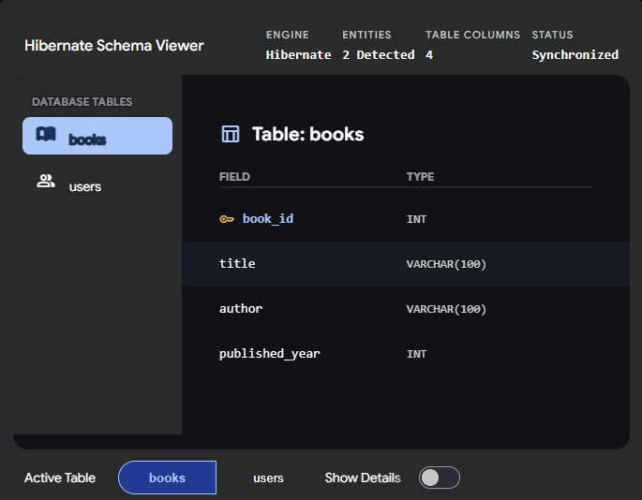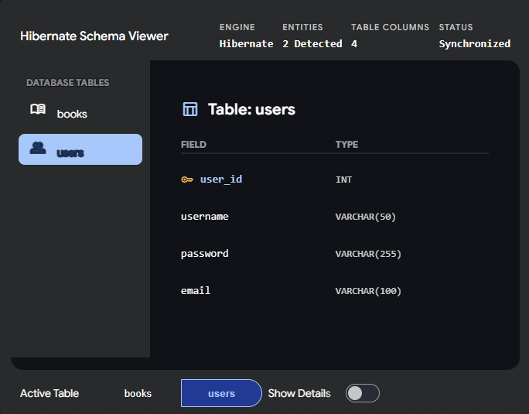

WEEK-11:
CRUD Operations: Implement CRUD operations using Hibernate for managing book
information in the database.

1.The Database Helper (HibernateUtil.java)

import org.hibernate.SessionFactory;
import org.hibernate.cfg.Configuration;
public class HibernateUtil {
private static final SessionFactory sessionFactory;
static {
try {
// Loads configuration and builds the session factory
sessionFactory = new Configuration().configure().buildSessionFactory();
} catch (Throwable ex) {
System.err.println("Initial SessionFactory creation failed." + ex);
throw new ExceptionInInitializerError(ex);
}
}

public static SessionFactory getSessionFactory() {
return sessionFactory;
}
}

2. The CRUD Implementation (BookDAO.java)

import org.hibernate.Session;
import org.hibernate.Transaction;
import java.util.List;
public class BookDAO {
// ---------------------------------------------------------
// CREATE: Add a new book to the database
// ---------------------------------------------------------
public void saveBook(Book book) {
Transaction transaction = null;
try (Session session = HibernateUtil.getSessionFactory().openSession()) {
transaction = session.beginTransaction();
session.save(book); // Hibernate automatically writes the INSERT SQL
transaction.commit();
} catch (Exception e) {
if (transaction != null) {
transaction.rollback(); // Undo changes if something goes wrong
}
e.printStackTrace();
}
}

// ---------------------------------------------------------
// READ: Get a specific book by its ID
// ---------------------------------------------------------
public Book getBook(int id) {
try (Session session = HibernateUtil.getSessionFactory().openSession()) {
return session.get(Book.class, id); // Hibernate writes the SELECT SQL
}
}

// ---------------------------------------------------------
// READ: Get a list of all books in the database
// ---------------------------------------------------------
@SuppressWarnings("unchecked")
public List<Book> getAllBooks() {
try (Session session = HibernateUtil.getSessionFactory().openSession()) {
// HQL (Hibernate Query Language) uses the Java class name, not the DB table name
return session.createQuery("from Book").list();
}
}

// ---------------------------------------------------------
// UPDATE: Modify an existing book's details
// ---------------------------------------------------------
public void updateBook(Book book) {
Transaction transaction = null;
try (Session session = HibernateUtil.getSessionFactory().openSession()) {
transaction = session.beginTransaction();
session.update(book); // Hibernate writes the UPDATE SQL
transaction.commit();
} catch (Exception e) {
if (transaction != null) {
transaction.rollback();
}
e.printStackTrace();
}
}

// ---------------------------------------------------------
// DELETE: Remove a book from the database
// ---------------------------------------------------------
public void deleteBook(int id) {
Transaction transaction = null;
try (Session session = HibernateUtil.getSessionFactory().openSession()) {
transaction = session.beginTransaction();

// First, fetch the book we want to delete
Book book = session.get(Book.class, id);
if (book != null) {
session.delete(book); // Hibernate writes the DELETE SQL
}

transaction.commit();
} catch (Exception e) {
if (transaction != null) {
transaction.rollback();
}
e.printStackTrace();
}
}
}

OUTPUT
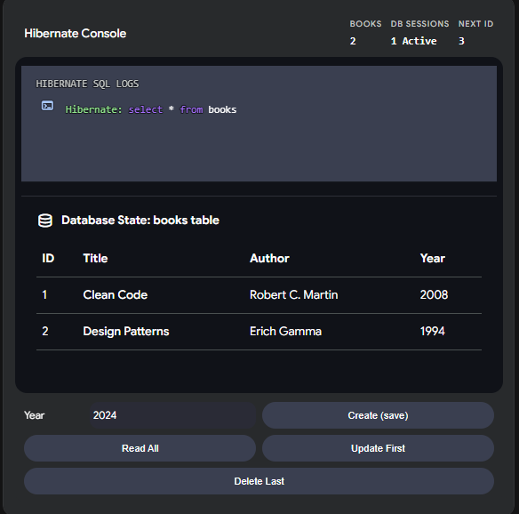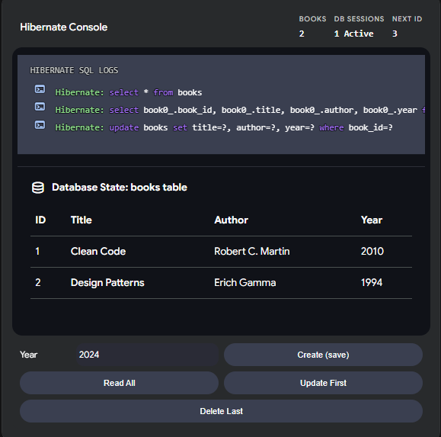

WEEK-12: Full-Stack Integration: Integrate JavaScript with Servlets: Enhance the shopping cart functionality by integrating JavaScript with servlets. Allow users to update the cart without page refresh.

1.The Frontend (cart.jsp)

<!DOCTYPE html>
<html>
<head>
<title>AJAX Shopping Cart</title>
<style>
body { font-family: Arial, sans-serif; padding: 20px; max-width: 500px; }
.cart-item { padding: 10px; border-bottom: 1px solid #ddd; display: flex; justify-content: space-between; align-items: center; }
.cart-item input { width: 50px; padding: 5px; }
.status-message { color: #28a745; font-size: 14px; display: none; margin-bottom: 10px; }
.total-row { margin-top: 20px; font-size: 1.2em; font-weight: bold; text-align: right; }
</style>
</head>
<body>

<h2>Your Shopping Cart</h2>
<div id="updateStatus" class="status-message">Cart updated successfully!</div>

<div class="cart-item">
<span>Clean Code ($40.00)</span>
<input type="number" value="1" min="1" onchange="updateCart(1, 40.00, this.value)">
</div>
<div class="cart-item">
<span>Design Patterns ($50.00)</span>
<input type="number" value="1" min="1" onchange="updateCart(2, 50.00, this.value)">
</div>

<div class="total-row">
Total: $<span id="cartTotal">90.00</span>
</div>

<script>
// JavaScript for asynchronous updating (AJAX)
function updateCart(bookId, price, quantity) {
// Send a background request to the Servlet
fetch('CartServlet', {
method: 'POST',
headers: { 'Content-Type': 'application/x-www-form-urlencoded' },
body: `bookId=${bookId}&price=${price}&quantity=${quantity}`
})
.then(response => response.json()) // The Servlet will return JSON data
.then(data => {
// Update the total on the screen dynamically
document.getElementById('cartTotal').innerText = data.newTotal;

// Flash a success message
let status = document.getElementById('updateStatus');
status.style.display = 'block';
setTimeout(() => { status.style.display = 'none'; }, 2000); // Hide after 2 seconds
})
.catch(error => console.error('Error updating cart:', error));
}
</script>
</body>
</html>

2. The Backend (CartServlet.java)

import java.io.*;
import javax.servlet.*;
import javax.servlet.annotation.WebServlet;
import javax.servlet.http.*;
@WebServlet("/CartServlet")
public class CartServlet extends HttpServlet {
protected void doPost(HttpServletRequest request, HttpServletResponse response)
throws ServletException, IOException {
// 1. Read the parameters sent by Javascript
int bookId = Integer.parseInt(request.getParameter("bookId"));
double price = Double.parseDouble(request.getParameter("price"));
int quantity = Integer.parseInt(request.getParameter("quantity"));
// 2. Business Logic: Update session cart and recalculate total
// Note: For this isolated example, we are just calculating the total of the changed item.
// In a real app, you would retrieve the user's cart object from the session and sum all items.
HttpSession session = request.getSession();
// Simulating a cart total calculation (Assuming they only have this one item type for the demo math)
// You would replace this with actual cart iteration logic.
double simulatedNewTotal = price * quantity;
// 3. Set the response content type to JSON
response.setContentType("application/json");
response.setCharacterEncoding("UTF-8");

// 4. Send the JSON response back to the Javascript fetch() call
PrintWriter out = response.getWriter();
out.print("{\"newTotal\": \"" + String.format("%.2f", simulatedNewTotal) + "\"}");
out.flush();
}
}

OUTPUT

